Elusen Cancr Plant Cymru
Welsh Children’s Cancer Charity

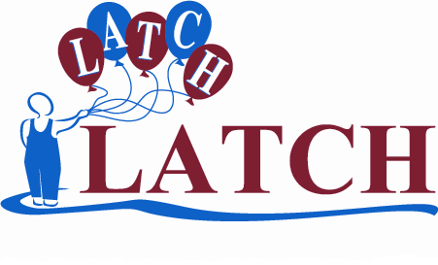
Swyddfa LATCH, Ysbyty Plant Cymru,  Parc Mynydd Bychan, Caerdydd, CF14 4XW  Ffôn. 029 2074 8858 Ffacs. 029 2074 8868  www.latchwales.org e-bost: latchcharity@aol.com | LATCH Office, Children’s Hospital for Wales,  Heath Park, Cardiff CF14 4XW  Tel. 029 2074 8858 Fax. 029 2074 8868  www.latchwales.org email: latchcharity@aol.com

DATGANIAD RHODD CYMORTH
GIFT AID DECLARATION

Enw Llawn
Full Name
Cyfeiriad
Address

Côd Post
Post Code
Rwyf yn datgan:
* y rhodd amgaeedig o £
* pob rhodd a wnaf o ddyddiad y datganiad hwn oni fynegaf yn wahanol i gael eu trin fel cyfraniadau rhodd cymorth fel y gall LATCH hawlio ad-daliad treth.
I declare that:
* the enclosed the donation of £
* All donations I make from the date of the declaration until I notify you otherwise are to be treated as Gift Aid and therefore LATCH is able to reclaim the tax.
Llofnod
Signature
Dyddiad
Date

Nodiadau / Notes
- Os yw eich datganiad yn berthnasol i rhoddion y byddwch o bosib yn eu gwneud yn y dyfodol, o.g.y.dd cysylltwch â LATCH os ydych chi’n newid eich enw neu’ch cyfeiriad tra fo’r datganiad yn dal mewn grym.
If your declaration covers donations you may make in the future please notify LATCH if you change your name or address whilst declaration is still in force.
- Gallwch ddiddymu’r datganiad ar unrhyw adeg wrth gysylltu â LATCH; yna ni fydd yn weithredol ar gyfer unrhyw roddion sy’n cael eu derbyn ar y dyddiad diddymu, nac ar ôl hynny.
You can cancel the declaration at any time by notifying LATCH; it will then not apply to donations you make on or after the date of cancellation or such later date as you specify.
- Mae’n rhaid eich bod chi’n talu cyfran o dreth incwm neu dreth ar enillion cyfalaf sy’n gyfesur â hynny o dreth y byddwn yn hawlio ar eich rhodd (28c o bob £1 ar hyn o bryd).
You must pay an amount of income tax or capital gains tax equal to the tax we reclaim on your donations (currently 28p for every £1 you give).
- NID OES lleiafswm na mwyafswm i faint y rhodd sy’n cael ei gydnabod fel rhodd cymorth.
There is NO minimum or maximum limit for the donation amount that is to be Gift Aided.

Rhif Elusen Cofrestredig / Registered Charity No. 1100949
Cwmni cyfyngedig trwy warant / A company limited by guarantee. Cofrestrwyd yn Lloegr, rhif / Registered in England, number 4735773
Prif Weithredwr / Chief Executive: Dr Eileen Thompson MBE MD FRCP DCH,
Cyn Lywydd Mygedol / Honorary Past President: Stan Stennett MBE, Is-Lywydd / Vice President: Roy Noble OBE,
Llysgennad Chwaraeon LATCH / LATCH Sports Ambassadors: Joe Calzaghe MBE World Champion, Sir David Richards Chairman Premier League.
Ffrindiau LATCH / Friends of LATCH: Dereck Brockway, Peter Karrie, Debbie Chapman, Jonathan Davies, Howard Griffiths, Nicola Heywood Thomas, Ruth Maddock, Owen Money, Jamie Owen, Juliet Piper, Jamie Shaw, Bonnie Tyler

