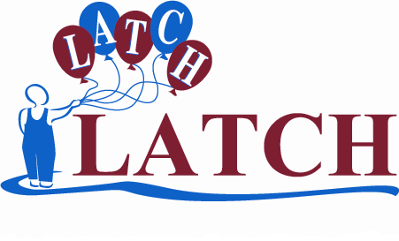
Ffurflen noddi ar gyfer taith gerdded llwybr arfordirol 125 milltir Ynys Môn
Sponsorship Form for walking the 125 mile Anglesey Coastal Path
(14/7/08 – 27/7/08)

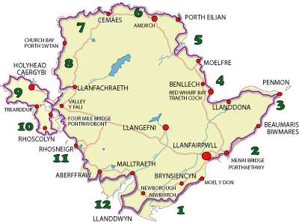
http://www.crwydromon.com/

Enw / Name: ............................................................

Cefnogwch ni i’w cefnogi nhw
Please help us to help them.

Am fwy o wybodaeth ewch i / For more info go to
www.llion.co.uk/latch

Elusen LATCH, Ysbyty Plant Cymru,  Parc Mynydd Bychan, Caerdydd, CF14 4XW  Ffôn. 029 2074 8858  Ffacs. 029 2074 8868  www.latchwales.org  e-bost: latchcharity@aol.com  Rhif Elusen Cofrestredig. 1100949 | LATCH Charity, Children’s Hospital for Wales,  Heath Park, Cardiff, CF14 4XW  Tel. 029 2074 8858  Fax. 029 2074 8868  www.latchwales.org  email: latchcharity@aol.com  Registered Charity No. 1100949

Enw llawn  Os ydych chi’n drethdalwr, o.g.y.dd ticiwch y blwch rhodd cymorth er mwyn i LATCH allu hawlio 28% yn ychwanegol at eich rhodd heb unrhyw gost i chi.  If you are a tax payer please tick the gift aid box and LATCH can claim an extra 28% on top of your donation. It won’t cost you a penny! | Cyfeiriad Cartref | Côd Post  Angenrheidiol ar gyfer rhodd cymorth | Swm a roddwyd | Dyddiad | Wedi’i gasglu? | Rhodd Cymorth  Ticiwch os gawn ni gasglu’r trethi ar eich rhodd.
Full name | Home Address | Postcode  Essential for gift aid | Amount donated | Date | Collected? | Gift Aid  Please tick if we can reclaim the tax on your donation.
Cyfanswm | / Total

Enw llawn  Os ydych chi’n drethdalwr, o.g.y.dd ticiwch y blwch rhodd cymorth er mwyn i LATCH allu hawlio 28% yn ychwanegol at eich rhodd heb unrhyw gost i chi.  If you are a tax payer please tick the gift aid box and LATCH can claim an extra 28% on top of your donation. It won’t cost you a penny! | Cyfeiriad Cartref | Côd Post  Angenrheidiol ar gyfer rhodd cymorth | Swm a roddwyd | Dyddiad | Wedi’i gasglu? | Rhodd Cymorth  Ticiwch os gawn ni gasglu’r trethi ar eich rhodd.
Full name | Home Address | Postcode  Essential for gift aid | Amount donated | Date | Collected? | Gift Aid  Please tick if we can reclaim the tax on your donation.
Cyfanswm | / Total

Enw llawn  If you are a tax payer please tick the gift aid box and LATCH can claim an extra 28% on top of your donation. It won’t cost you a penny!  Os ydych chi’n drethdalwr, o.g.y.dd ticiwch y blwch rhodd cymorth er mwyn i LATCH allu hawlio 28% yn ychwanegol at eich rhodd heb unrhyw gost i chi. | Cyfeiriad Cartref | Côd Post  Angenrheidiol ar gyfer rhodd cymorth | Swm a roddwyd | Dyddiad | Wedi’i gasglu? | Rhodd Cymorth  Ticiwch os gawn ni gasglu’r trethi ar eich rhodd.
Full name | Home Address | Postcode  Essential for gift aid | Amount donated | Date | Collected? | Gift Aid  Please tick if we can reclaim the tax on your donation.
Cyfanswm | / Total

Cwblhewch hwn ar ôl i chi gasglu’ch holl arian nawdd.
Please fill this in when you have collected all your sponsorship money.

Enw / Name .................................... | Dychwelwch y ffurflen hon ynghyd â’r arian a gasglwyd at:  Please return this form with the money you raised to:
Cyfeiriad / Address ....................................
.................................................................. | Swyddfa LATCH  Ysbyty Plant Cymru  Parc Mynydd Bychan  Caerdydd  CF14 4XW | The LATCH Office  Children’s Hospital for Wales  Heath Park  Cardiff  CF14 4XW
Côd Post / Post Code ....................................
Ffôn / Tel. ....................................
E-bost / E-mail ....................................
Cyfanswm / Total £ .................................... | neu cysylltwch / or contact:  Llion Marc Evans (latch@llion.co.uk)
 | Gwnewch eich sieciau yn daladwy i LATCH o.g.y.dd.
 | Please make cheques payable to LATCH

